Marat/Pieta/TOTC Triplet Analysis

Text 1: Excerpt from Dickens’ A Tale of Two Cities: Book 3: Ch. 5

But, though the Doctor tried hard, and never ceased trying, to get Charles Darnay set at liberty, or at least to get him brought to trial, the public current of the time set too strong and fast for him. The new era began; the king was tried, doomed, and beheaded; the Republic of Liberty, Equality, Fraternity, or Death, declared for victory or death against the world in arms; the black flag waved night and day from the great towers of Notre Dame; three hundred thousand men, summoned to rise against the tyrants of the earth, rose from all the varying soils of France, as if the dragon’s teeth had been sown broadcast, and had yielded fruit equally on hill and plain, on rock, in gravel, and alluvial mud, under the bright sky of the South and under the clouds of the North, in fell and forest, in the vineyards and the olive-grounds and among the cropped grass and the stubble of the corn, along the fruitful banks of the broad rivers, and in the sand of the sea-shore. What private solicitude could rear itself against the deluge of the Year One of Liberty—the deluge rising from below, not falling from above, and with the windows of Heaven shut, not opened!

There was no pause, no pity, no peace, no interval of relenting rest, no measurement of time. Though days and nights circled as regularly as when time was young, and the evening and morning were the first day, other count of time there was none. Hold of it was lost in the raging fever of a nation, as it is in the fever of one patient. Now, breaking the unnatural silence of a whole city, the executioner showed the people the head of the king—and now, it seemed almost in the same breath, the head of his fair wife which had had eight weary months of imprisoned widowhood and misery, to turn it grey.

And yet, observing the strange law of contradiction which obtains in all such cases, the time was long, while it flamed by so fast. A revolutionary tribunal in the capital, and forty or fifty thousand revolutionary committees all over the land; a law of the Suspected, which struck away all security for liberty or life, and delivered over any good and innocent person to any bad and guilty one; prisons gorged with people who had committed no offence, and could obtain no hearing; these things became the established order and nature of appointed things, and seemed to be ancient usage before they were many weeks old. Above all, one hideous figure grew as familiar as if it had been before the general gaze from the foundations of the world—the figure of the sharp female called La Guillotine.

It was the popular theme for jests; it was the best cure for headache, it infallibly prevented the hair from turning grey, it imparted a peculiar delicacy to the complexion, it was the National Razor which shaved close: who kissed La Guillotine, looked through the little window and sneezed into the sack. It was the sign of the regeneration of the human race. It superseded the Cross. Models of it were worn on breasts from which the Cross was discarded, and it was bowed down to and believed in where the Cross was denied.

Text 2:
Jean Paul Marat
Marat was born in Boudry, Switzerland but had the French nationality.
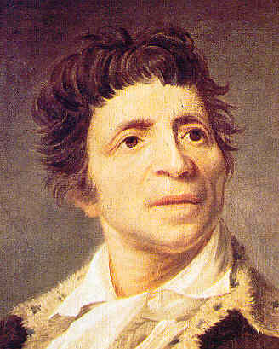
Portrait of Marat by Joseph Boze (1793)

Marat's Education
At 16 years old, Marat left his parents to study medicine in France and later, in England. He was a pretty renowned scientist; he worked on physics and published some of his works on energy from fire and on electricity.
His work was criticized by the French famous "Academy des Sciences" and his membership to the famous institution was rejected several times.

Marat became journalist
The political events in France and more particularly the opening of the General Estates, gave Marat the opportunity to express his disapproval of the regime in another way.
He became a journalist with radical ideas when other newspapers published still very liberal points of views. In September 1789, he started his own newspaper "L'ami du peuple" ("Friend of the people") where he attacked the enemies of the Revolution.
The French crowd was found of these articles where the conservatives are criticized at every level of the French society, even inside the "Tiers-Etats". He was pretty aggressive towards Necker and La Fayette who he thought didn't disserve their plebiscite.

Marat's Extremism
On July 14th, 1789 at the Storming of the Bastille, Marat declared that five to six hundreds heads should be cut in order to install a new regime. His goal was to eliminate all the people near or far related to the king.
In 1792, he talked about his wish to see a new dictatorship installed where the true values of the Revolution will be implemented. His extremist ideas were accused to have led to the massacre of September 1792.

Marat's Political Ascension
That same month, Marat was elected to the National Convention where he sat with the "Montagnards". He renamed his famous newspaper to "le journal de la republique francaise" (the journal of the French republic).
In 1793, he was elected president of the Jacobins club and asked for the destitution of the Girondins, whom he believed where enemies of the republicanism. On the other side, the Girondins attacked the dictatorship of the Montagnards and their famous leaders, Robespierre,
Danton and Marat.
The battle between to two parties ended on June 2nd, 1793. The Convention decided to eliminate the Girondins. This was a very important victory for Marat, who became even more popular.
On July 13th, 1793 Marat was murdered by Charlotte Corday, a Girondin sympathiser.
The Republic gave him a national honor with grandiose funeral. On his tombstone was engraved these words, "Here sleeps Marat, the friend of the people who was killed by the enemies of the people on July 13th, 1793".
On September 21st, 1794 Marat was officialy declared an "Immortel" and exhumed to the Pantheon.

Jean Paul Marat's dead illustrated by Jacques Louis David (1793)
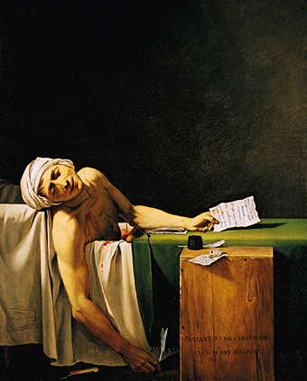

The Death of Marat has often been compared to Michelangelo's Pietà. Note the elongated arm hanging down in both works. David admired Caravaggio's works, especially Entombment of Christ, which mirrors The Death of Marat's drama and light.
David sought to transfer the sacred qualities long associated with the monarchy and the Catholic Church to the new French Republic. He painted Marat, martyr of the Revolution, in a style reminiscent of a Christian martyr, with the face and body bathed in a soft, glowing light.^{[2]} As Christian art had done from its beginning, David also played with multileveled references to classical art. Suggestions that Paris could compete with Rome as capital and mother city of the Arts and the idea of forming a kind of new Roman Republic appealed to French Revolutionaries, who often formed David's audience

Text 3: Michelangelo’s Pieta

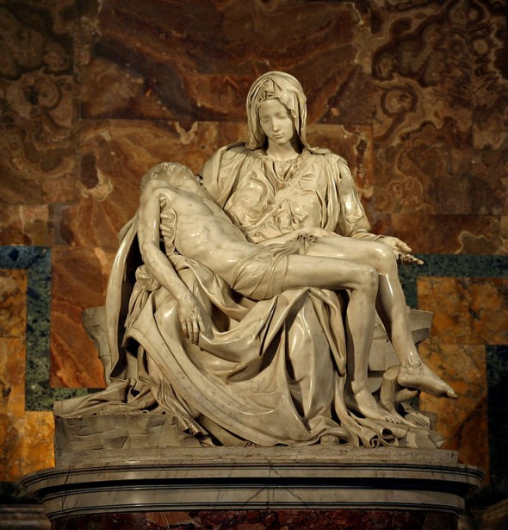
Michelangelo, Pieta, c. 1498-1500, marble
Michelangelo carved a number of works in Florence during his time with the Medici, but in the 1490s he left Florence and briefly went to Venice, Bologna, and then to Rome, where he lived from 1496-1501. In 1497, a cardinal named Jean de Billheres commissioned Michelangelo to create a work of sculpture to go into a side chapel at Old St. Peter’s Basilica in Rome. The resulting work – the Pieta – would be so successful that it helped launch Michelangelo’s career unlike any previous work he had done.
Michelangelo claimed that the block of Carrara marble he used to work on this was the most “perfect” block he ever used, and he would go on to polish and refine this work more than any other statue he created.
The scene of the Pieta shows the Virgin Mary holding the dead body of Christ after his crucifixion, death, and removal from the cross, but before he was placed in the tomb. This is one of the key events from the life of the Virgin, known as the Seven Sorrows of Mary, which were the subject of Catholic devotional prayers. The subject matter was one which would have probably been known by many people, but in the late fifteenth century it was depicted in artworks more commonly in France and Germany than in Italy.

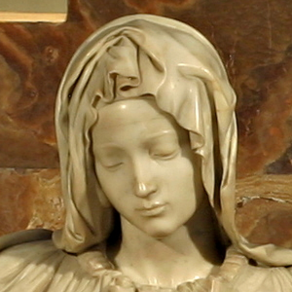An examination of each figure reveals that their proportions are not entirely natural in relation to the other. Although their heads are proportional, the Virgin’s body is larger than Christ’s body. She appears so large that if she stood up, she would likely tower over her son. The reason Michelangelo did this was probably because it was necessary so that the Virgin could support her son on her lap; had her body been smaller, it might have been very difficult or awkward for her to have held an adult male as gracefully as she does. To assist in this matter, Michelangelo has amassed the garments on her lap into a sea of folded drapery to make her look larger. While this drapery serves this practical purpose, it also allowed Michelangelo to display his virtuosity and superb technique when using a drill to cut deeply into the marble. After his work on the marble was complete, the marble looked less like stone and more like actual cloth because of its multiplicity of natural-looking folds, curves, and deep recesses.
In her utter sadness and devastation, she seems resigned to what has happened, and becomes enveloped in graceful acceptance. Michelangelo’s talent in carving drapery is matched by his handling of the human forms in the Christ and the Virgin, both of whom retain a sweet tenderness despite the very tragic nature of this scene. This is, of course, the moment when the Virgin is confronted with the reality of the death of her son. In her utter sadness and devastation, she seems resigned to what has happened, and becomes enveloped in graceful acceptance. Christ, too, is depicted almost as if he is in a peaceful slumber, and not one who has been bloodied and bruised after hours of torture and suffering. In supporting Christ, the Virgin’s right hand does not come into direct contact with his flesh, but instead it is covered with a cloth which then touches Christ’s side. This signifies the sacredness of Christ’s body. Overall, these two figures are beautiful and idealized, despite their suffering. This reflects the High Renaissance belief in Neo-Platonic ideals in that beauty on earth reflected God’s beauty, so these beautiful figures were echoing the beauty of the divine.
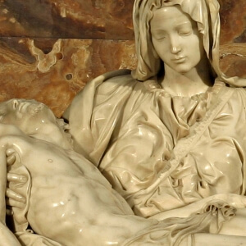Around the time the work was finished, there was a complaint against Michelangelo because of the way he depicted the Virgin. She appears rather young – so young, in fact, that she could scarcely be the mother of a thirty-three-year-old son. Michelangelo’s answer to this criticism was simply that women who are chaste retain their beauty longer, which meant that the Virgin would not have aged like other women usually do.

